Shopnest Store Power BI

1.Top Categories by Total Price:

Identify and visually represent the top 10 product categories by total sales.

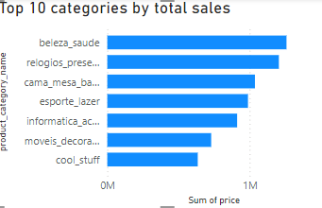

Here beleza_saude top category with the highest total revenue.

2. Delayed Orders Analysis:

Determine the number of delayed orders in each category. An order is considered delayed if the actual delivery date is later than the estimated delivery date

Cama_mesa_banho has the most delayed delivery with a count of 769

3. Monthly Comparison of Delayed and On-Time Orders:

Create a dynamic visual that compares the number of delayed orders to the number of orders received earlier for each month. Utilize the drillthrough cross-report feature to provide a detailed analysis of late and on-time deliveries.

4. Payment Method Analysis:

Analyze the most frequently used payment methods by customers using a visually appealing representation, such as a pie chart or other suitable visuals

Credit card payments appear to be the highest used payment method and debit card is low

5. Product Rating Analysis:

Determine the top 10 highest-rated products and the bottom 10 lowest-rated products using a bar or column chart.

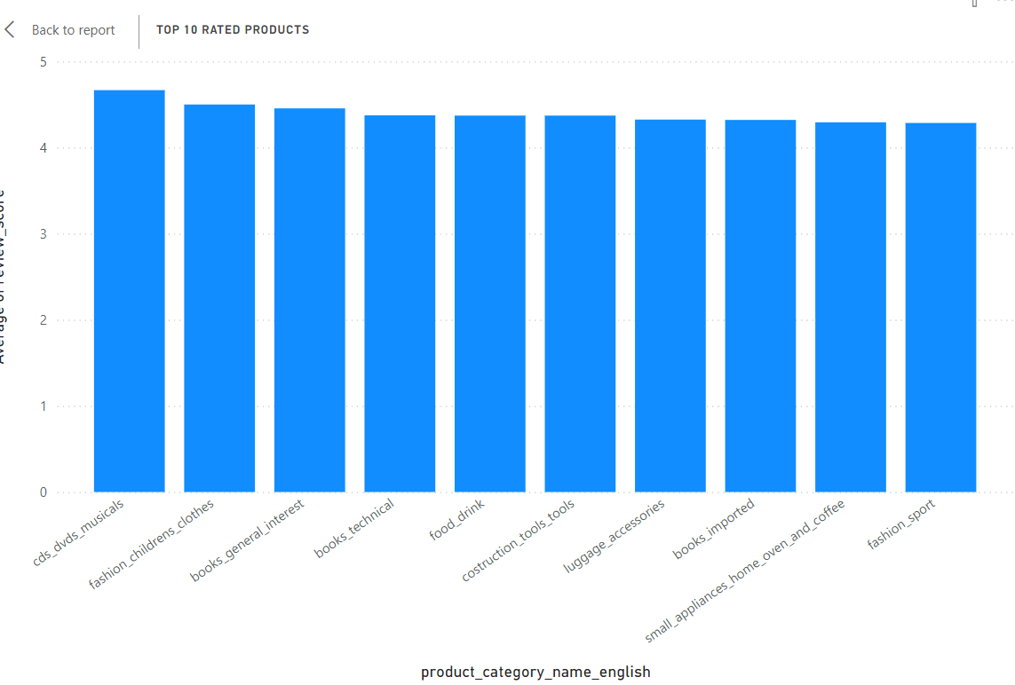

cds_dvds_musicais is highest popular among customers, as they have high average review scores

Diapers and Hygiene is lowest amont customers because of its average review score

6. State-wise Sales Analysis:

Identify and visually represent states with high and low sales, providing a clear understanding of regional sales performance

States like SP, RJ, and MG appear to contribute high to that total revenue, with the highest sums of prices

7. Seasonal Sales Patterns:

Investigate and visualize any seasonal patterns(Quarterly) or trends in sales data over the course of the year

8. Revenue Analysis:

Determine the total revenue generated by ShopNest Store and analyze how it changes over time(Yearly). Represent this information through suitable visuals to highlight trends and patterns

